**BVRITH INTRANET MOBILE APP**

Sara Fathima1, CH Sripriya2, Nisha3, K Naresh4

1,2,3,4Department of Computer Science Engineering, BVRIT HYDERABAD College of Engineering for Women, Hyderabad, Telangana, India

[118wh1a0542@bvrithyderabad.edu.in,](mailto:118wh1a0542@bvrithyderabad.edu.in,) [218wh1a0557@bvrithyderabad.edu.in,](mailto:218wh1a0557@bvrithyderabad.edu.in,)

[319wh5a0505@bvrithyderabad.edu.in,](mailto:319wh5a0505@bvrithyderabad.edu.in,) [4naresh.k@bvrithyderabad.edu.in](mailto:4naresh.k@bvrithyderabad.edu.in)

**Abstract.** The Usage of mobile devices in our daily life has resulted in a technological and cultural shift in the society. The availability of information through this medium is fundamentally changing how we conduct our daily activities, such as searching, shopping, interacting with the government, and learning. As we all know mobile apps are user friendly and easy to access so, we want to develop an app called intranet which includes some of the features of our website called ecap and extra features like student graduate survey, student leaves, student achievements, faculty achievements, faculty leaves, course attainments, etc.

## Introduction

**Problem Statement:**

Developing a complete, integrated android based mobile application to provide students with information regarding college administration details, Departmental details, Placement activities, Library books details, Hostel details, Transportation details, and so on.

**Objective:**

Students, faculty, and administration will all use this mobile application. In the previous system, all information is viewed on the website. At the same time, it is very difficult to access information and it takes a long time to search in a specific website. Hence, in order to overcome this problem a smart phone based mobile application using Android can be used to make this process easier, secure and less error prone.

# Proposed System:

Intranet is a real time application that can be installed on any Android devices and improve interactivity, accessibility and convenience in the learning process. This application consists of extra features like Placement details, Students Achieve ments and Certifications.

# System Environment and Architecture

The following technology stack for developing the application

*Andriod Studio :*

The official integrated development environment for Google's Android operating system is Android Studio.

It offers an uniform development environment for Android phones, tablets, Android Wear, Android TV, and Android Auto.

*Xampp:*

XAMPP is a free and open-source cross-platform web server solution stack package that also supports databases such as MariaDB and SQLite.

*NetBeans:*

NetBeans IDE is a free and open source integrated development environment (IDE) for creating desktop, mobile, and web applications. The IDE facilitates the building of applications in a variety of languages, including Java, HTML5, PHP, and C++.

*Apache Server :*

The Apache HTTP Server is a cross-platform web server that is free and open-source software released under the Apache License 2.0. Under the aegis of the Apache Software Foundation, Apache is created and maintained by an open community of developers.

*MySQL:*

MySQL is a relational database management system that is free and open source. That means it assists you in storing all of your blog posts, users, plugin information, and so on for WordPress sites. It is relational because it keeps information in different "tables" and relates it with "keys."

*Java:*

Java is an object-oriented programming language with a high level of abstraction and as few implementation dependencies as possible.

Java is used to create applications for several platforms that run the Java Runtime Environment (JRE), as well as applications that run on a single device such as a desktop or mobile phone. Java can also be used to create distributed applications.

# Methodology

**ARCHITECTURE:**

# 

Whenever the user sends the request controller receives the request from user and sends the same request to service and it sends the same request to DAO and it will fetch all the details from Database according to the request and it send back the data to service and service will sends to controller. Now controller will give response to the user.

**ADMIN USE CASE:**

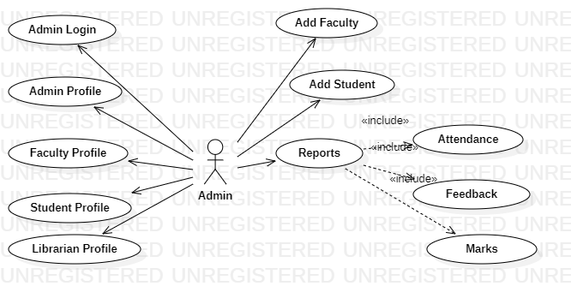

**LIBRARIAN USE CASE**

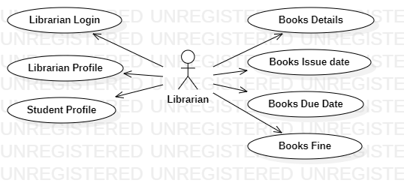

**FACULTY USE CASE**

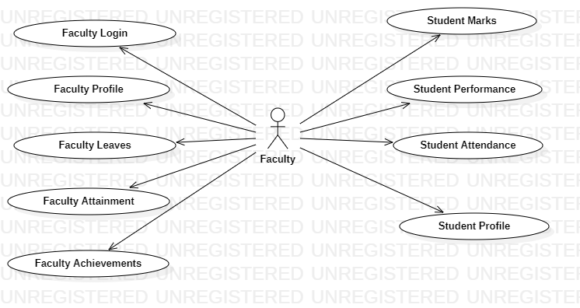

**STUDENT USE CASE**

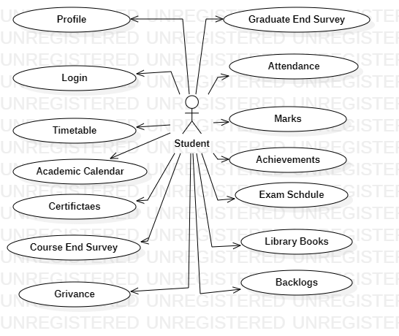

**MOBILE WEB VERSUS NATIVE APPS**

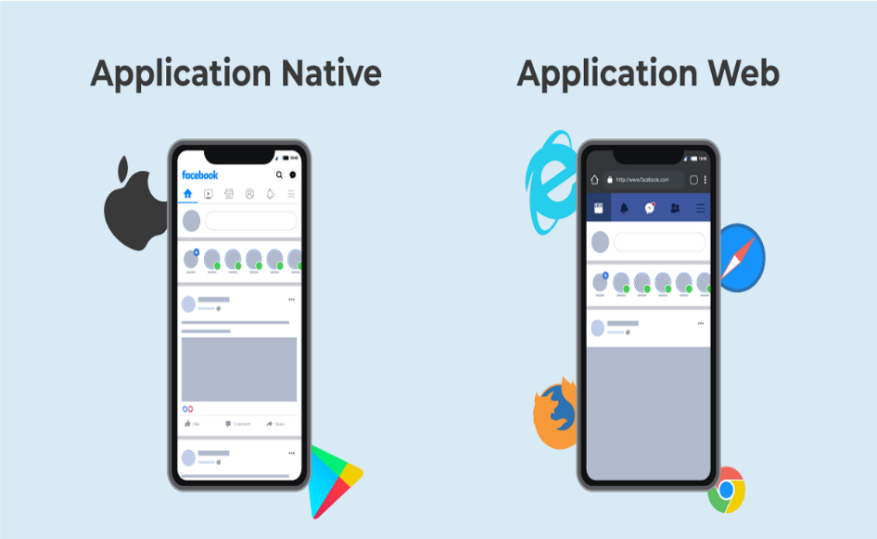

**Native Apps:** Native apps are built specifically for a mobile operating system and are installed on the device itself. App retailers such as Apple App Store, Google Play Store, and others sell these apps.

Native apps are faster than web apps.

These apps have more safety and security than web apps, as native apps must be approved by the App Store.

**Web Apps:** Web Apps are internet-enabled applications that may be accessed using the mobile device's Web browser. We do not need to download and install the app on our mobile device to gain access.

Web apps work slower than mobile apps.

Web apps are more dangerous and of lower quality, and there is no guarantee of security because they are not required to be vetted by app stores

# Conclusion

We conclude that blockchain based solution for image sharing provides many benefits over existing image sharing systems. The blockchain based image sharing applications provides security for the user accounts, permanent record of images, providing profit for the users who posted the image in the form of crypto currency ethers. Due to the absence of central authority the image sharing is free from rights and interference. After the evaluation, we conclude that decentralized systems are better for building image sharing applications. The blockchain transactions contain IPFS hashes for retrieving the images. By encrypting the content before in the smart contract with some encryption algorithms and then transferring these information to IPFS, data security is provided. This implementation is scalable as we are storing the hashes of images on blockchain network instead of images itself. Thus the paper illustrates an important use case to overcome the problems faced by using centralized image sharing applications.

# Future Scope

Decentralized networks have the potential to expand in popularity and be used as a new normal. The obvious advantages, especially the increased reliability over centralized networks attest to this prediction. As developers grow familiar with this system, a massive increment in usage of decentralized networks can be expected; slowing overtaking and replacing centralized networks. Eventually, a lot more developments and functionalities will emerge in decentralized networks, further multiplying it’s benefits. The system developed as a part of the academic work is a proof of concept. The real world challenges that need to be addressed are scalability, profitability, Regulatory aspects etc. A thorough research is required to integrate the existing system with AI/ML algorithms to address issues such as crime, nudity, fake posts etc.

# References

* + 1. Shilpi, Taneja., Goel, Anita. (2015). Mobile Applications in Educational Insti- tutions. Computational Intelligence Communication Technology (CICT), 2015 IEEE International Conference on. IEEE, 2015.
    2. Nikhlil Jadhav1 , Bhupesh Singh2 , Kunal Lunge3 , Gopi Mali 4 , Nilesh Patil, Android Application for College Management System, in IJESC Volume 6 Issue No. 12 , 2016.
    3. K. Vivek Thangam1 ,T. Shyam Kumar2 ,V.Yogesh kumar3 and S.Prabhu4, ANDROID APPLICATION FOR COLLEGE MANAGEMENT SYSTEM (M-INSPROPLUS),IJMTER,volume-4,issue no-2.
    4. Mrunmayee V. Rane;Vikram M. Apte;Vishakha N. Nerkar;Mani Roja Edinburgh;K.Y. Rajput; (2021). Automated Timetabling System for University Course . 2021 International Conference on Emerging Smart Computing and Informatics (ESCI).
    5. Alif Fatihi Abdul Fatah;Roslina Mohamad;Farah Yasmin Abdul Rahman;Nur'ain Izzati Shuhaimi; (2021). Student Attendance System Using An Android Based Mobile Application . 2021 IEEE 11th IEEE Symposium on Computer Applications &amp; Industrial Electronics (ISCAIE)
    6. S. Bhattacharya, "Blue-Droid: An Intelligent Library Management System on Android Platform," IOSR Journal of Computer Engineering (IOSR-JCE)- 2014.
    7. Shada, Gabriella Sekar; Ayu, Media Anugerah (2018). [IEEE 2018 International Conference on Computing, Engineering, and Design (ICCED) - Bangkok, Thailand (2018.9.6-2018.9.8)] 2018 International Conference on Computing, Engineering, and Design (ICCED) - Designing Android User Interface for University Mobile Library.
    8. Ankit Bansal 1,Ajit Rana 2,Akhil Bansod 3,Prafulla Baviskar 4, Mobile based campus Information Retrieval Android Application, in IJCSMC, Vol.4, Is- sue.3,March 2015
    9. https://sbphptricks.blogspot.com/2020/03/insert-data-into-database-using.html
    10. [https://www.youtube.com/w](http://www.youtube.com/watch?v=KOXwulnDfIo)atch?v=K[OXwulnDfIo](http://www.youtube.com/watch?v=KOXwulnDfIo)
    11. *https://www.simplifiedcoding.net/android-upload-image-using-php-mysql-android-studio/*
    12. *https://www.youtube.com/watch?v=D-w3WXR6ltE&t=188s*
    13. *https://www.youtube.com/watch?v=4e8be8xseqE&t=299s*